Sunday | Monday | Tuesday | Wednesday | Thursday | Friday | Saturday
 |  |  |  |  | 1 | 2
3 | 4 | 5 | 6 | 7 | 8 | 9
10 | 11  Columbus Day (US)  Indigenous Peoples’ Day  Thanksgiving (Canada) | 12 | 13 | 14 | 15 | 16
17 | 18 | 19 | 20 | 21 | 22 | 23
24 | 25 | 26 | 27 | 28 | 29 | 30
31

Halloween

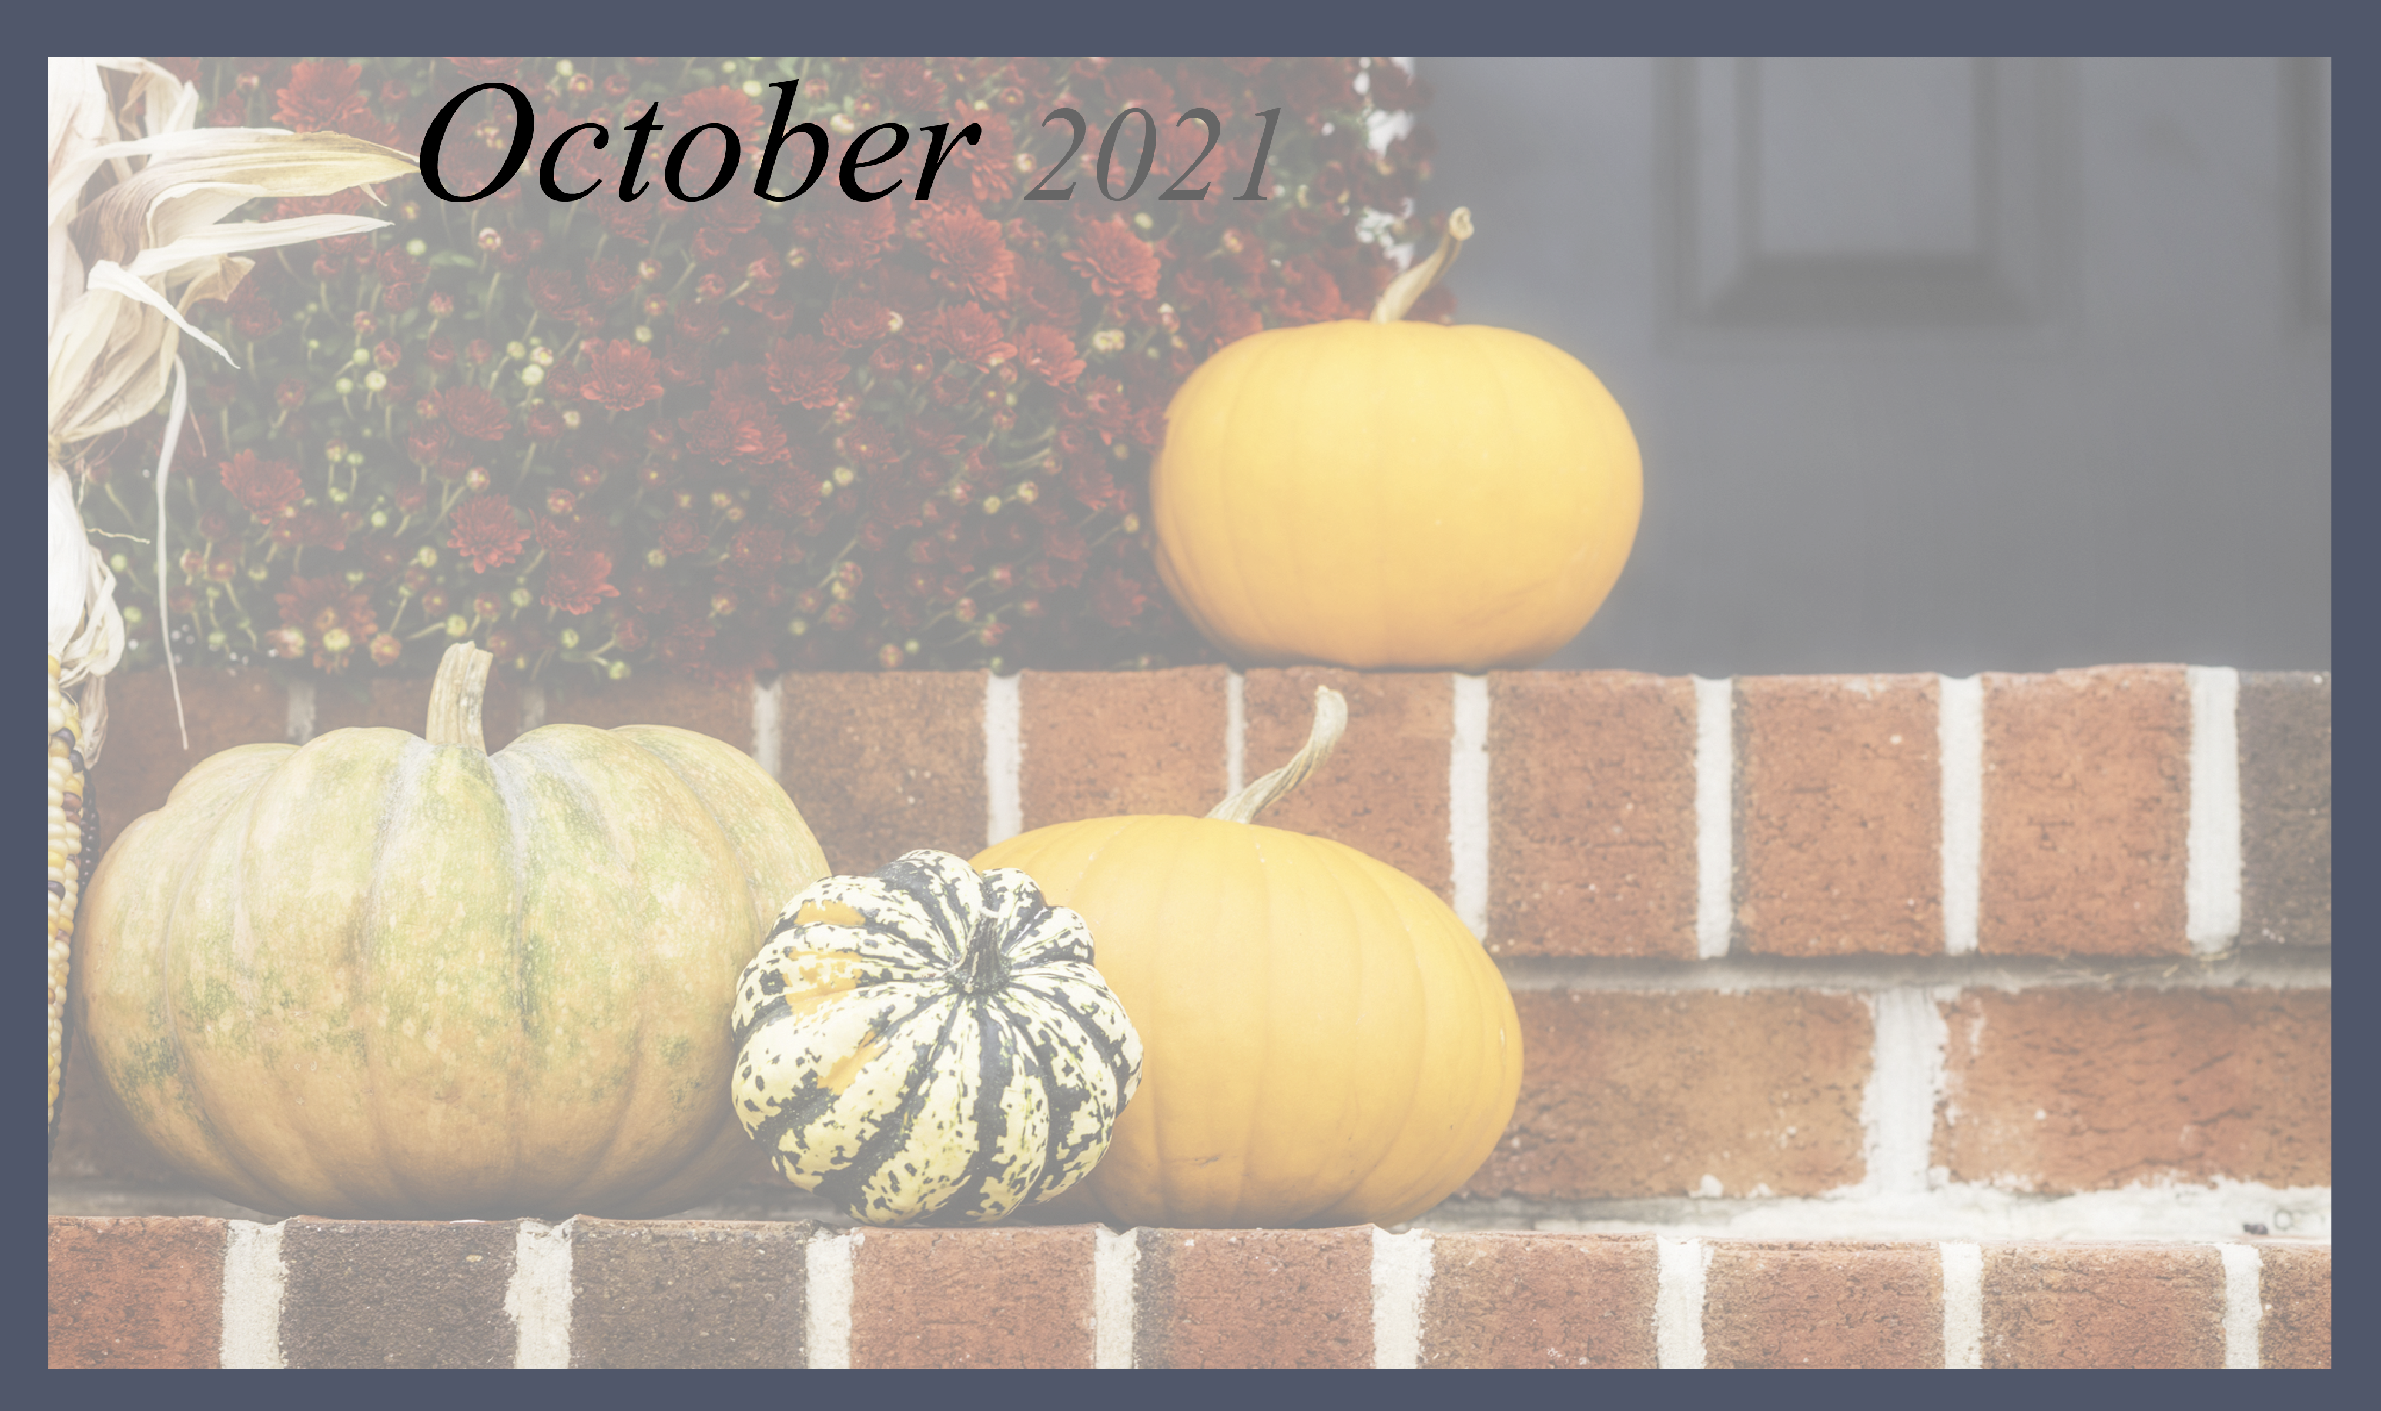  Activities Director-Elizabeth Cylka,  Activities Aides – Terry C and Alexis B. |  |  |  |  | 10:30 Zumba  11:00 soccer  2:00 left-right -center  3:00 spot the difference  4:00 Happy hour | 10:00 Sing along  11:00 Fun/ Wild Trivia  1:30 lets take a walk  2:00 Afternoon movie with popcorn
10:00 mass on tv  11:00 Coffee and Danish  11:30 Morning Walk  1:30 Tailgate party  Texans Vs Bills  5:00 Lawrence welk Memories | 10:00 Monday news &Views  10:30 Sit and be Fit  11:00 lets be Detectives  1:30 Creative Craft  5:30 October Crafts | Golden Arches Day  10:00 Travel Tuesday  11:00 Volleyball Fun  2:00 McDonald French Fries  3:00 Amazing Facts about McDonald  5:30 Evening walks about | German American Day  10:00 Chair dancing with German Music  10:30 German Trivia (TS)  11:00 let’s take a walk  2:00 Art Class (TS)  5:30 German Bingo (TS) | 10:30 Bible study w/ Amy  1:30 Out and about: the Pumpkin Patch  3:00 Happy Hour (TS)  5:30 Creative Craft | 10:00 Sit and Be fit  10:30 Silly word games  2:00 Bowling alley  3:00 Happy hour Fun (TS) | 10:30 Sing along  11:00 What do you know?  1:30 lets get moving  2:00 afternoon Movie with Popcorn (TS)
10:00 mass on tv  11:00 Coffee and Danish  11:30 Morning Walk  1:30 The Bills Make me want to shout Craft (TS)  5:30 POP POP POP  Corn Cart (TS) | 10:00 Monday News /Views  10:30 Sit and be Fit  11;00 Rhythm Band  2:00 Art Class | 10:00 travel Tuesday  10:30 big Band Memories  11:00 Spelling Bee  (Halloween Words)  1:30 On this day in History  3:00 Happy Hour  5:30 Evening Walk about | 10:00 30 Sit and Be Fit  10:30 Spot it  1:30 A Around the world  3:00 Happy Hour  5:30 Bean Bag Toss | 10:30 Bible with Amy  11:00 Rosary with Amy  1:30 Mystery Ride  2:00 Lets be Detectives (TS)  5:30 After dinner walk | 10:00 Zumba  11:00 How things Changed  2:00 Happy Birthday all the September Babies Party | 10:30 Trivia fun with Terri  11;00 Sing along 50’s Music  11:30 walking Club  2:00 Saturday Afternoon Movie Fun with Popcorn
10:00 Mass on TV  10:30 Coffee And Danish  11:00 Sunday Morning Walk  2;00 20 Questions  3:00 Bean Bag Toss  5:30 Lawrence Welk Memories | 10:00 Sit and Be Fit  10:30 Lets beat the  Monday Blues  1:30 Cooking up:  Pumpkin Pie  3:00 Chair Yoga | 10:00 Sit and be Fit  10:30 Tuesday Travel  1:30 Good old days  3:00 afternoon Coffee and Danish  5:30 Fireside chats | 10:00 Sit and Be Fit  10:30 Wild History  Wednesday  2:00 Art Class (TS)  3:00 Manicures  5:30 50’s Trivia | 10:00 Zumba  10:30 Bible study with Amy  1:30 Mystery ride  2:00 Tic tac Toss  3:00 Happy Hour  5:30 toss and Talk | 10:00 sit and be Fit  10:30 Hit the target  1:30 On this day in history  3:00 Happy Hour | 10:00 Sing a long  11:00 1950’s Trivia  1:30 After lunch walk  2:00 Afternoon Movie with popcorn
10:00 mass on tv  11:00 Coffee and Danish  11:30 Morning Walk | 10:30 Addams  Family Exercise (TS)  11:00 Cooking Up :  Caramel Apples  2:00 Halloween Bingo Fun  3:00 Pumpkin Carving (TS) | 10:30 Cand Corn toss  11:00 Jack o’ Lantern  memory Game (TS)  2:00 Cooking Up: Witches Brooms  5:30 Newsy Conversation | 10:30 Wild Witch Exercise (  11:00 Halloween Humor  2:00 Art Class (TS)  3:00 Pumpkin Chuck (TS)  4:00 Happy Hour | 10:30 Bible Study  With Amy (C)  11:00 Rosary (C )  1:30 Mystery Ride  2:00 Halloween Crafts  3:00 Happy Hour  5:30 Hollywood Portraits | 10:30 Lets do the Monster Mash (Zumba )  11:00 Funny Frankenstein  Flicks  2:00 Halloween Staff and Resident Fashion show TS | 10:30 Remembering Halloween Songs  11:00 Halloween Trivia  1:30 Halloween Movie hour
10:00 mass on tv  11:00 Coffee and Danish  11:30 Morning Walk  1:30 Tailgate Party | *** Activities are Subject to Change **  Towne Square – TS  Chapel – C  Orchard Park Living Room -OLR Music Room- MR  Park Living Room – PLR  Orchard Kitchen – OK Park Kitchen-PK
Peregrine Senior Living at Orchard Park , 101 Sterling DR. Orchard park NY 14127

